Math 61 Learning Unit 2 Hand-In Assignment for Section 3.4
© Problems copyright Stefan Waner 2015 All rights reserved

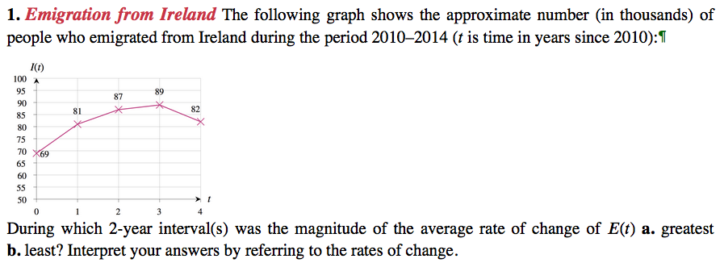
¶ Source: European Migration Network Ireland http://emn.ie.
Hint: See Section 3.4 Exercise 31 for a similar problem in the book.

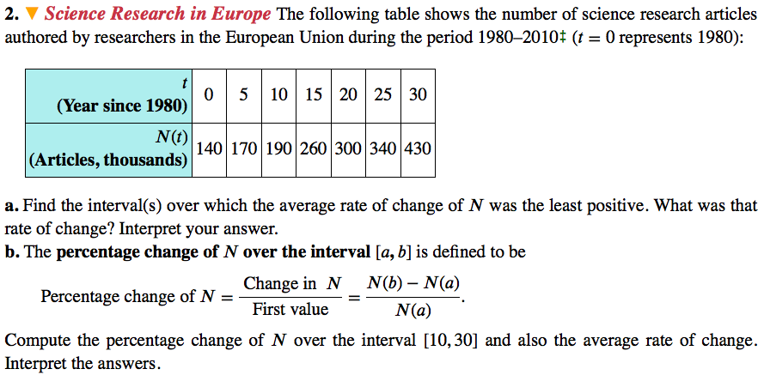
‡ 1980 data estimated. Source: http://www.sciencewatch.com
Hint: Similar to Section 3.4 Exercise 33 in the book.

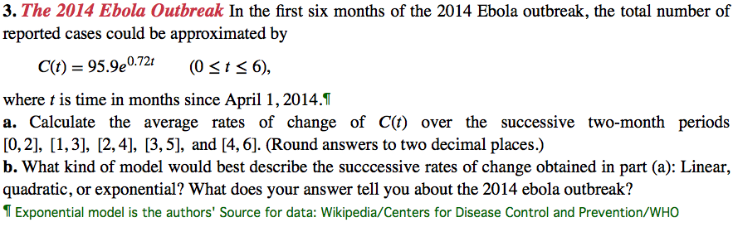
Hint: Similar to Section 3.4 Exercise 45 in the book.

